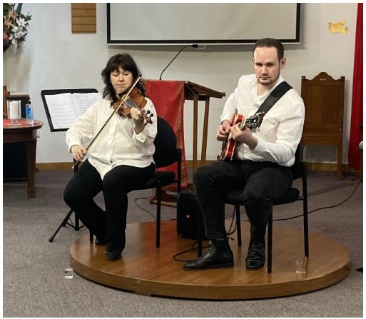

Music Lovers at Kenmore invite you to their next concert to be held on Thursday October 16th, at Kenmore Uniting Church, Moggill Road, Kenmore.  On this occasion we will be welcoming back to Music Lovers, Classical Guitarist Matthew Teakle. Matthew is a Brisbane based guitarist, cellist and educator.  He studied jazz guitar at the Queensland Conservatorium, Griffith University and graduated with first Class Honours and a University Medal.  During this time, Matthew became highly regarded as a versatile and enthusiastic performer, regularly performing in styles ranging from hip hop to modern classical music at a high level.  As a Cellist, Matthew regularly performs with the Queensland Youth Symphony Orchestra and the Brisbane Philharmonic Orchestra.  As guitarist, he holds the principal Guitar chair in the Queensland Jazz Orchestra and is a prominent band leader and sideman on the Brisbane jazz scene.

We are also looking forward to the welcome return of Irina Lgotkina. Irina was born in Yekaterinburg, Russia. She gained a PhD in violin performance from Yekaterinburg Conservatory & toured Western Europe as a performer from an early age. For the past five years Irina has been based in Brisbane, where she remains an active performer. Irina has appeared with various ensembles and orchestras, including the Brisbane Symphony Orchestra. the Bach Society and the Amadeus Orchestra when she recently played a solo role in their production of Mozart's Requiem Mass in D minor. She also collaborates with Ady-ensemble projects.  In addition, Irina has performed on many occasions at Music Lovers.

We are looking forward to a splendid morning, so please join us.

Kenmore Uniting Church, 982 Moggill Road, Kenmore.

10 am to 11.30 with a short interval for light Morning Tea. Entry at the door $10, to include morning tea.

Enquiries to the Church Office on 3378 4505 or [kenmoreuc01@gmail.com](mailto:kenmoreuc01@gmail.com)